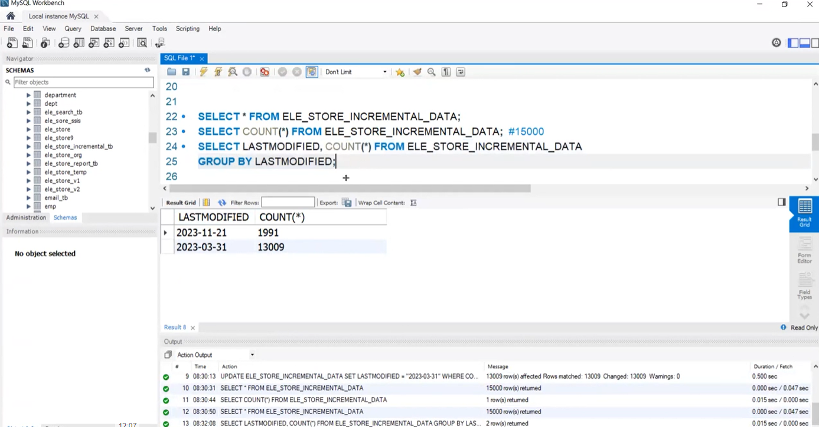

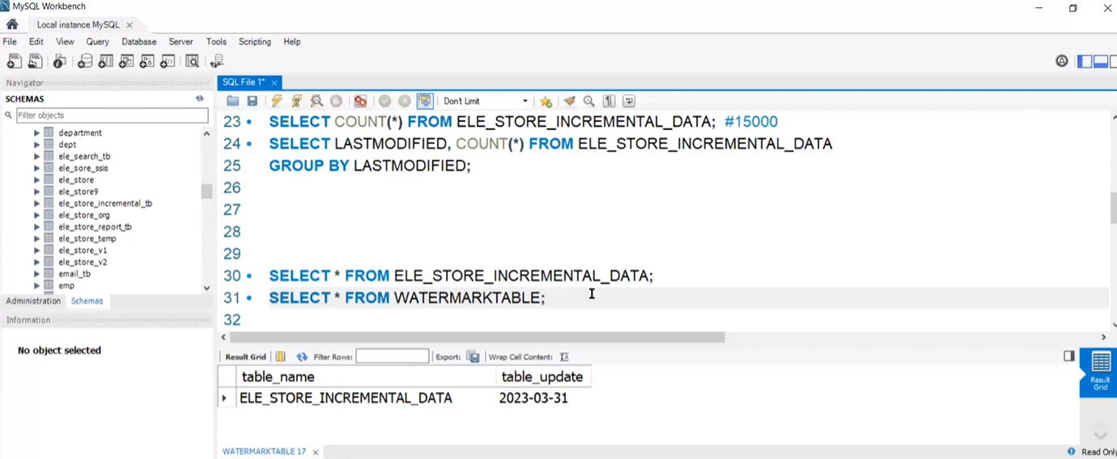

Requirement – Load only incremental data (only data of 21-11-2023)

**Scenario** – I have 10 years of data but I am interested in loading only last one year of data, remaining 9 years is old data, how do you go about this?

**Answer -**

Use the following -

Column – last modified date

Table – Watermark table

1. Create SQL Database

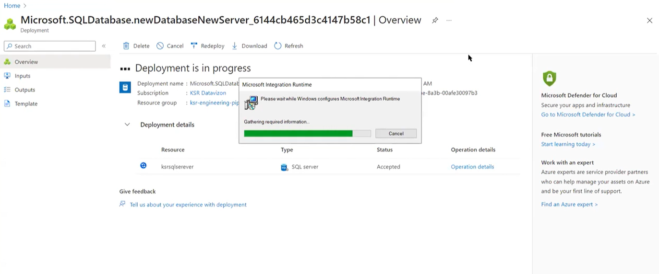

1. Create ADF – lookup activity

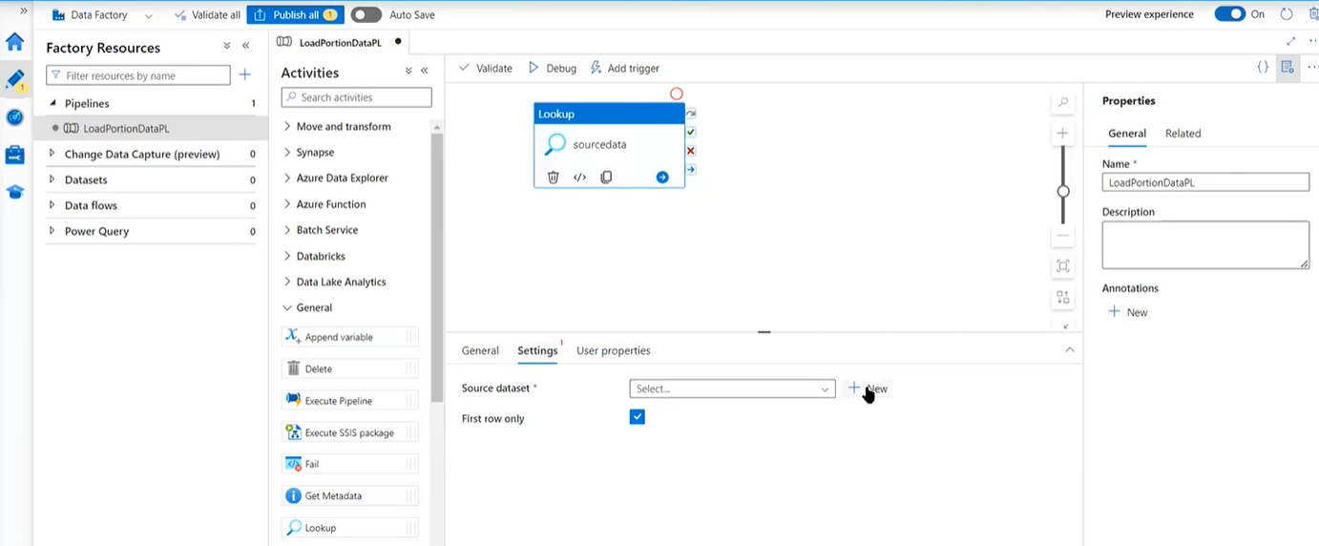

Source – linkedservice (sql to adf) using SHIR (remember to uninstall if using express setup)

1. Add another lookup (watermark based on watermark table)

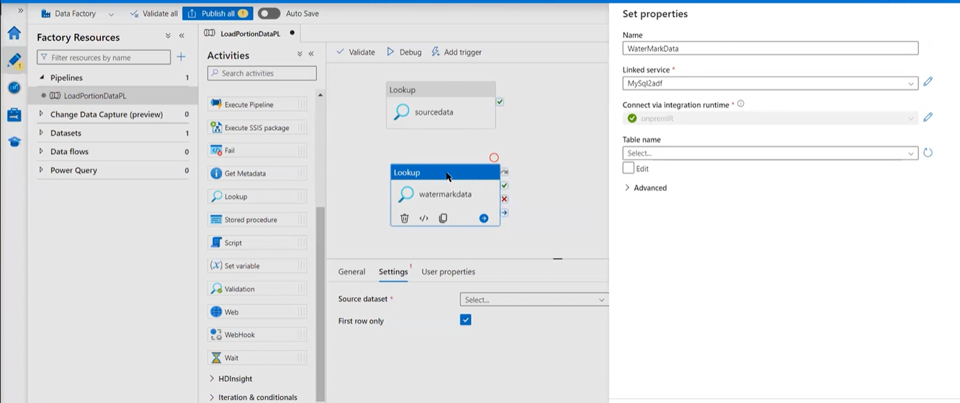

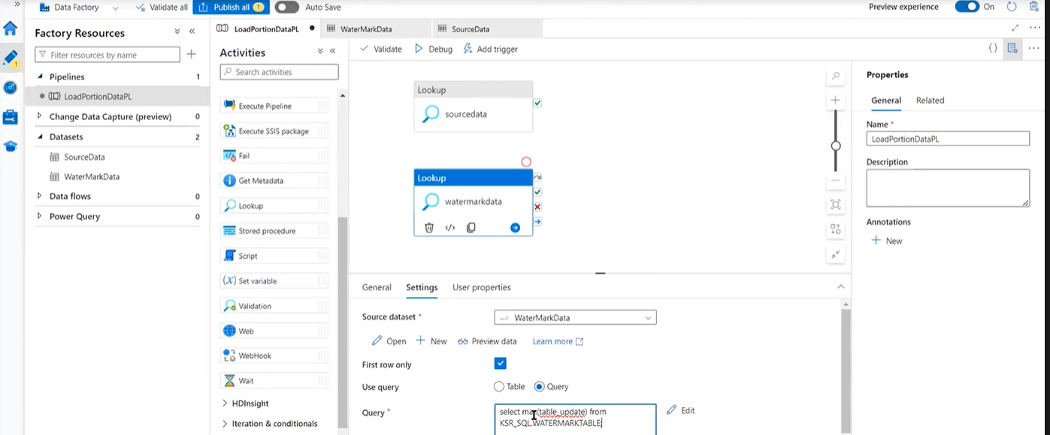

Watermark reference table will contain the max(update_date)

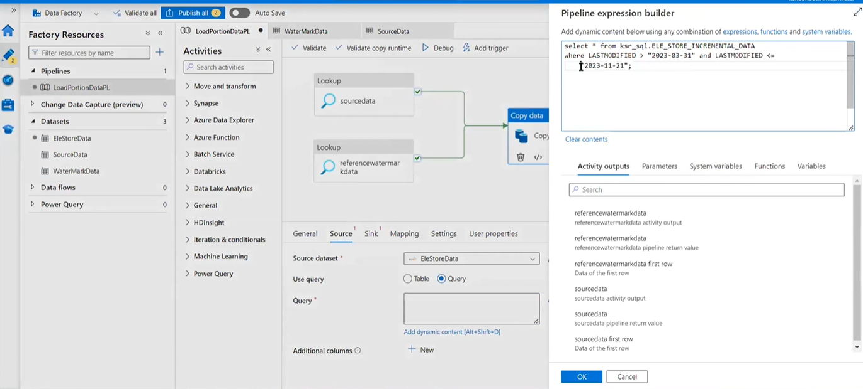

Copy activity has to copy the latest incremental date data only, so use Dynamic content for Query

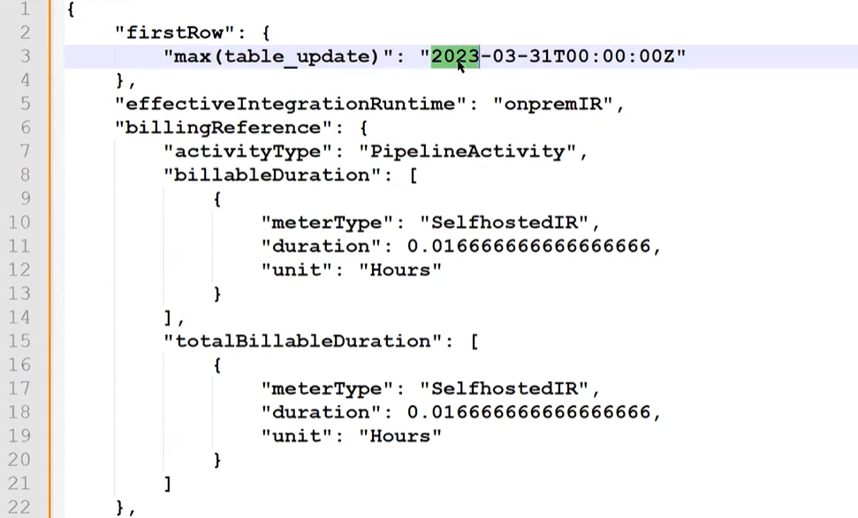

Source data

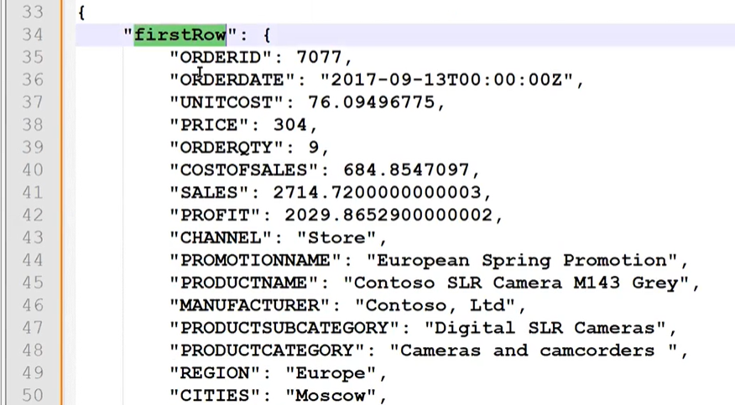

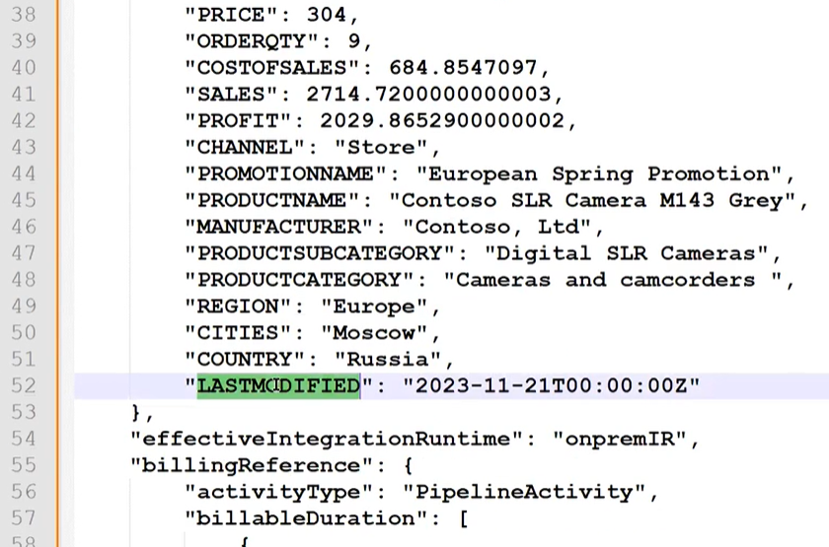

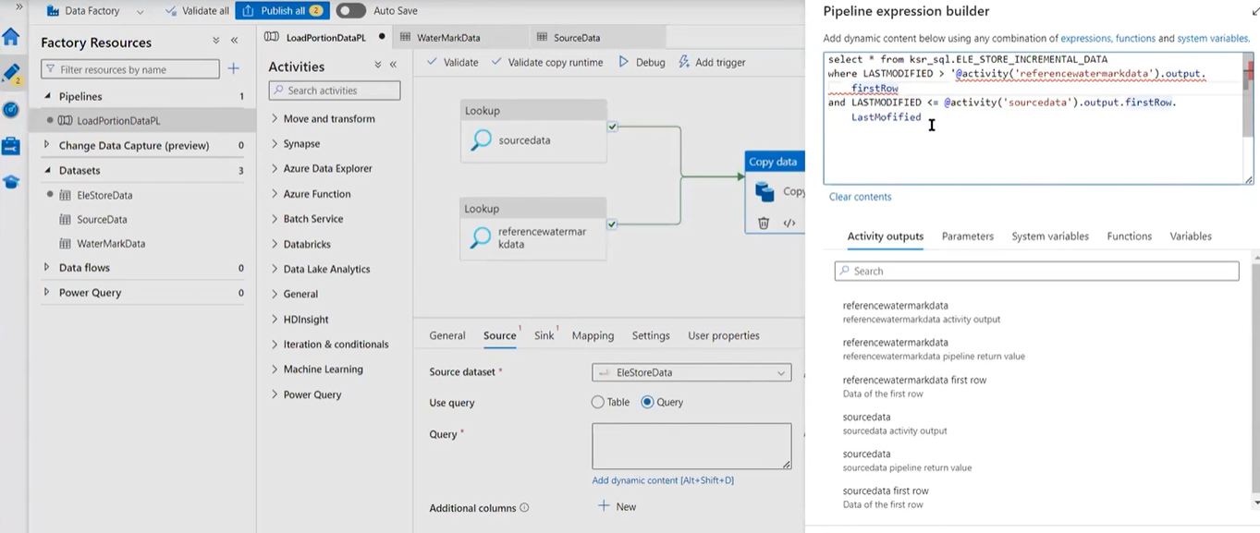

Giving alias to column name as LUD (last updated date)

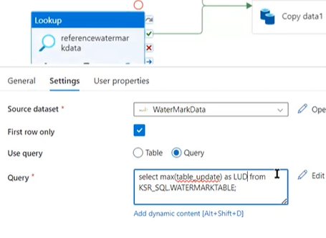

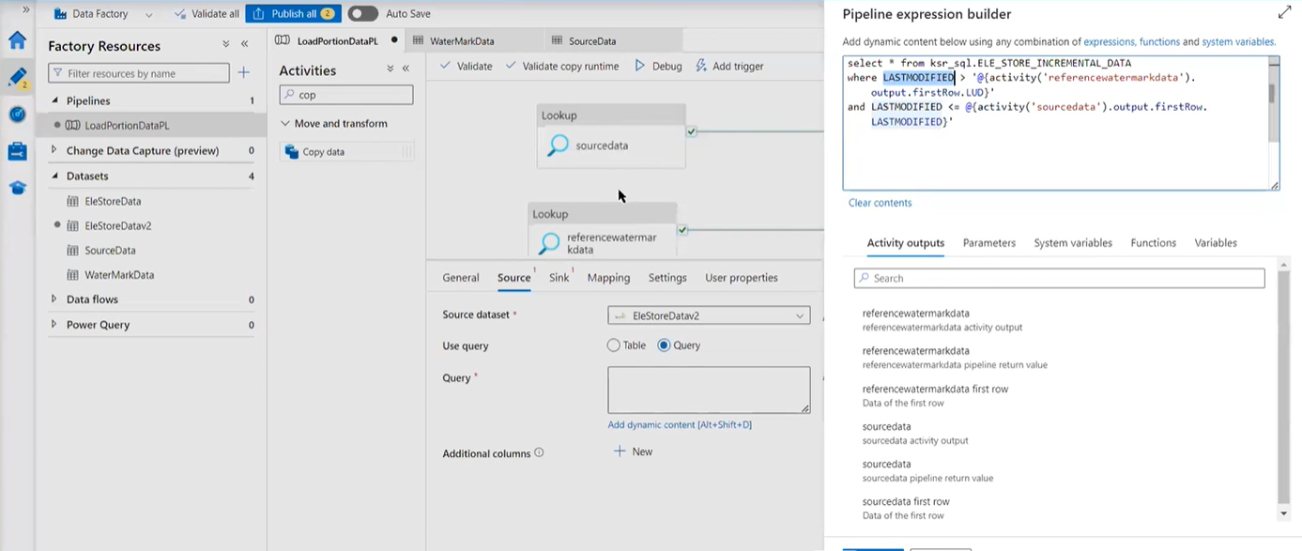

Sink – Azure SQL server, create the linked service

Publish > trigger now

